C# Programming - Class 2
Assignment 05: Creating applications with ADO.NET

Step 1: Research
In this activity module, you will learn about the classes of ADO.NET and how they are used to create a data driven application.

- Please review the following Videos on using SQL Server (AS NEEDED)
http://www.asp.net/learn/sql-videos/

- Please watch the following videos:

1_AnOverviewOfADO.NET
2_UsingTheConnectionClass
3_UsingTheCommandClass
4_UsingTheDataReaderClass
5_UsingTheDataAdapterClass
6_CreatingAnADONetApplication

Step 2: Applying your knowledge
In this activity, you reviewed web tutorials and watch videos created by your instructor on the basics of programming with ADO.NET. Let’s apply this knowledge by creating an application that uses ADO.Net code.

- Create a new database called Assignment05 and table called Persons to hold a person’s FirstName, LastName, and PhoneNumber.

- Create a windows application form that allows users to insert textbox data into the Persons table. Please do your work by hand without using the wizards provided by Visual Studio.

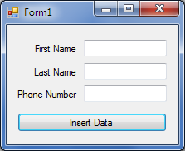

Step 3: Submitting your work.
Homework is graded, so you need to submit it. However, I will demonstrate the solution at the beginning of the next class and it is best if you have your version of the homework available to you while I do so. This way, you can compare your solution to mine and ask questions.

